Personal Progress Temples

In trying to find a way to further motivate the YW to do personal progress, we came up with the idea of tracking their personal progress on a temple that they eventually would be able to take home.

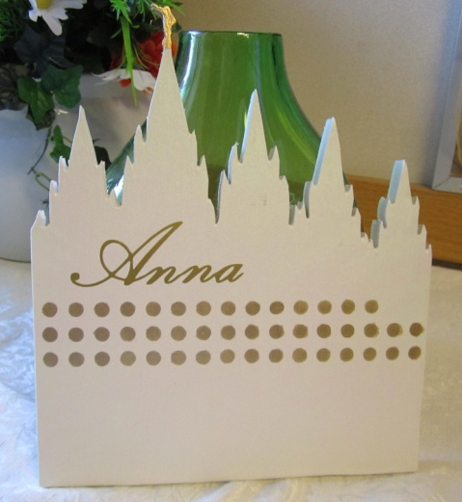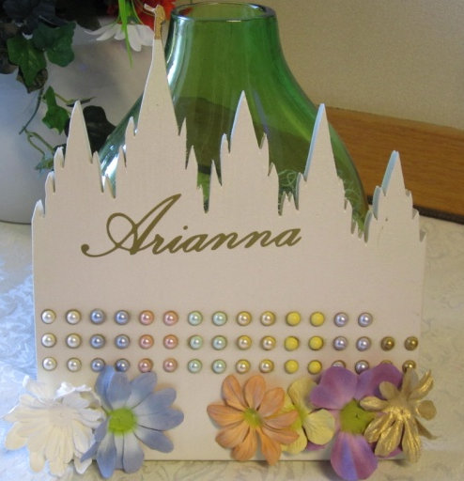

The Process… We first designed the outline of a temple with spires (see attached outline). We traced the outline onto a block of ¾ inch plywood measuring about 9x12. Then we cut out the temple with a scroll saw. We lightly sanded the edges of the temple and in between the spires to smooth corners and get rid of splinters. Next, we painted the temples with a shimmery white paint (or you could paint it with flat white paint and spray over it with a clear pearl paint to give it the shimmer). We cut out the dots on a vinyl sticker with a vinyl cutting machine (see attached template). We attached the sticker in the middle of the temple and spray painted it gold. Then removed the dot template sticker to reveal 46 gold dots. We also painted Moroni gold. We placed a sawtooth picture hanger on the back of the temple. Finally, we cut out each girl’s name on a gold vinyl sticker with a vinyl cutting machine and placed it at the top of the temple.

Value Experiences… Each gold dot on the temple corresponds with a Personal Progress value experience. When a girl has completed a value experience, she gets to put a pearl sticker of that value’s color on her temple on top of a gold dot. We placed them in order with two consecutive rows of dots of the same value so that we would know how many of each value she has left to complete. For example, the first two rows are for Faith (white pearls), rows 3 & 4 are for Divine Nature (blue pearls), rows 5 & 6 are for Individual Worth (red pearls), etc. There are only four places for pearls on the last two rows, which are for Virtue’s four experiences. The pearls were purchased from Michaels (a local craft store) and are called “Martha Stewart Sticker 3D Pearls” (http://www.michaels.com/Martha-Stewart-Crafts%E2%84%A2-White-Dimensional-Pearl-Stickers/wd0233,default,pd.html?cgid=products-scrapbooking-marthastewartcrafts-embellishements&start=1 ). We were able to find them in every color except for yellow (Good Works) and gold (Virtue), so we just took some extra white pearls and spray painted them the needed colors. They are stickers, but we used a little bit of super glue to attach them to make sure that they would stick forever.
Value Projects… When the girls complete a value project, they get a flower of the corresponding color to decorate the base of the temple (like landscaping). We also purchased the paper flowers from the craft store in each of the value colors to use for the value projects. We did not find paper flowers in gold, but we used the gold spray paint to tint the edges of some of the white flowers. The ones we bought are called “Recollections Boutique Fleur Mulberry Paper Flowers” from Michaels (http://www.michaels.com/Recollections-Boutique-Fleur-Mulberry-Paper-Flowers/sb1413,default,pd.html?cgid=products-scrapbooking-recollections-embellishments&start=70 ). We got a small bucket of multi-colored flowers and a bucked of white flowers. We used double sided tape to attach the paper stickers to the base of the temple.
Completion… We have the temples on the wall in our YW room at church so that the girls can see their progress and encourage each other. When a girl has completed her personal progress we have a Young Womenhood Recognition night for her. Then we send the temple home with the girl to help her remember that personal progress will help her begin her progress toward the temple!

