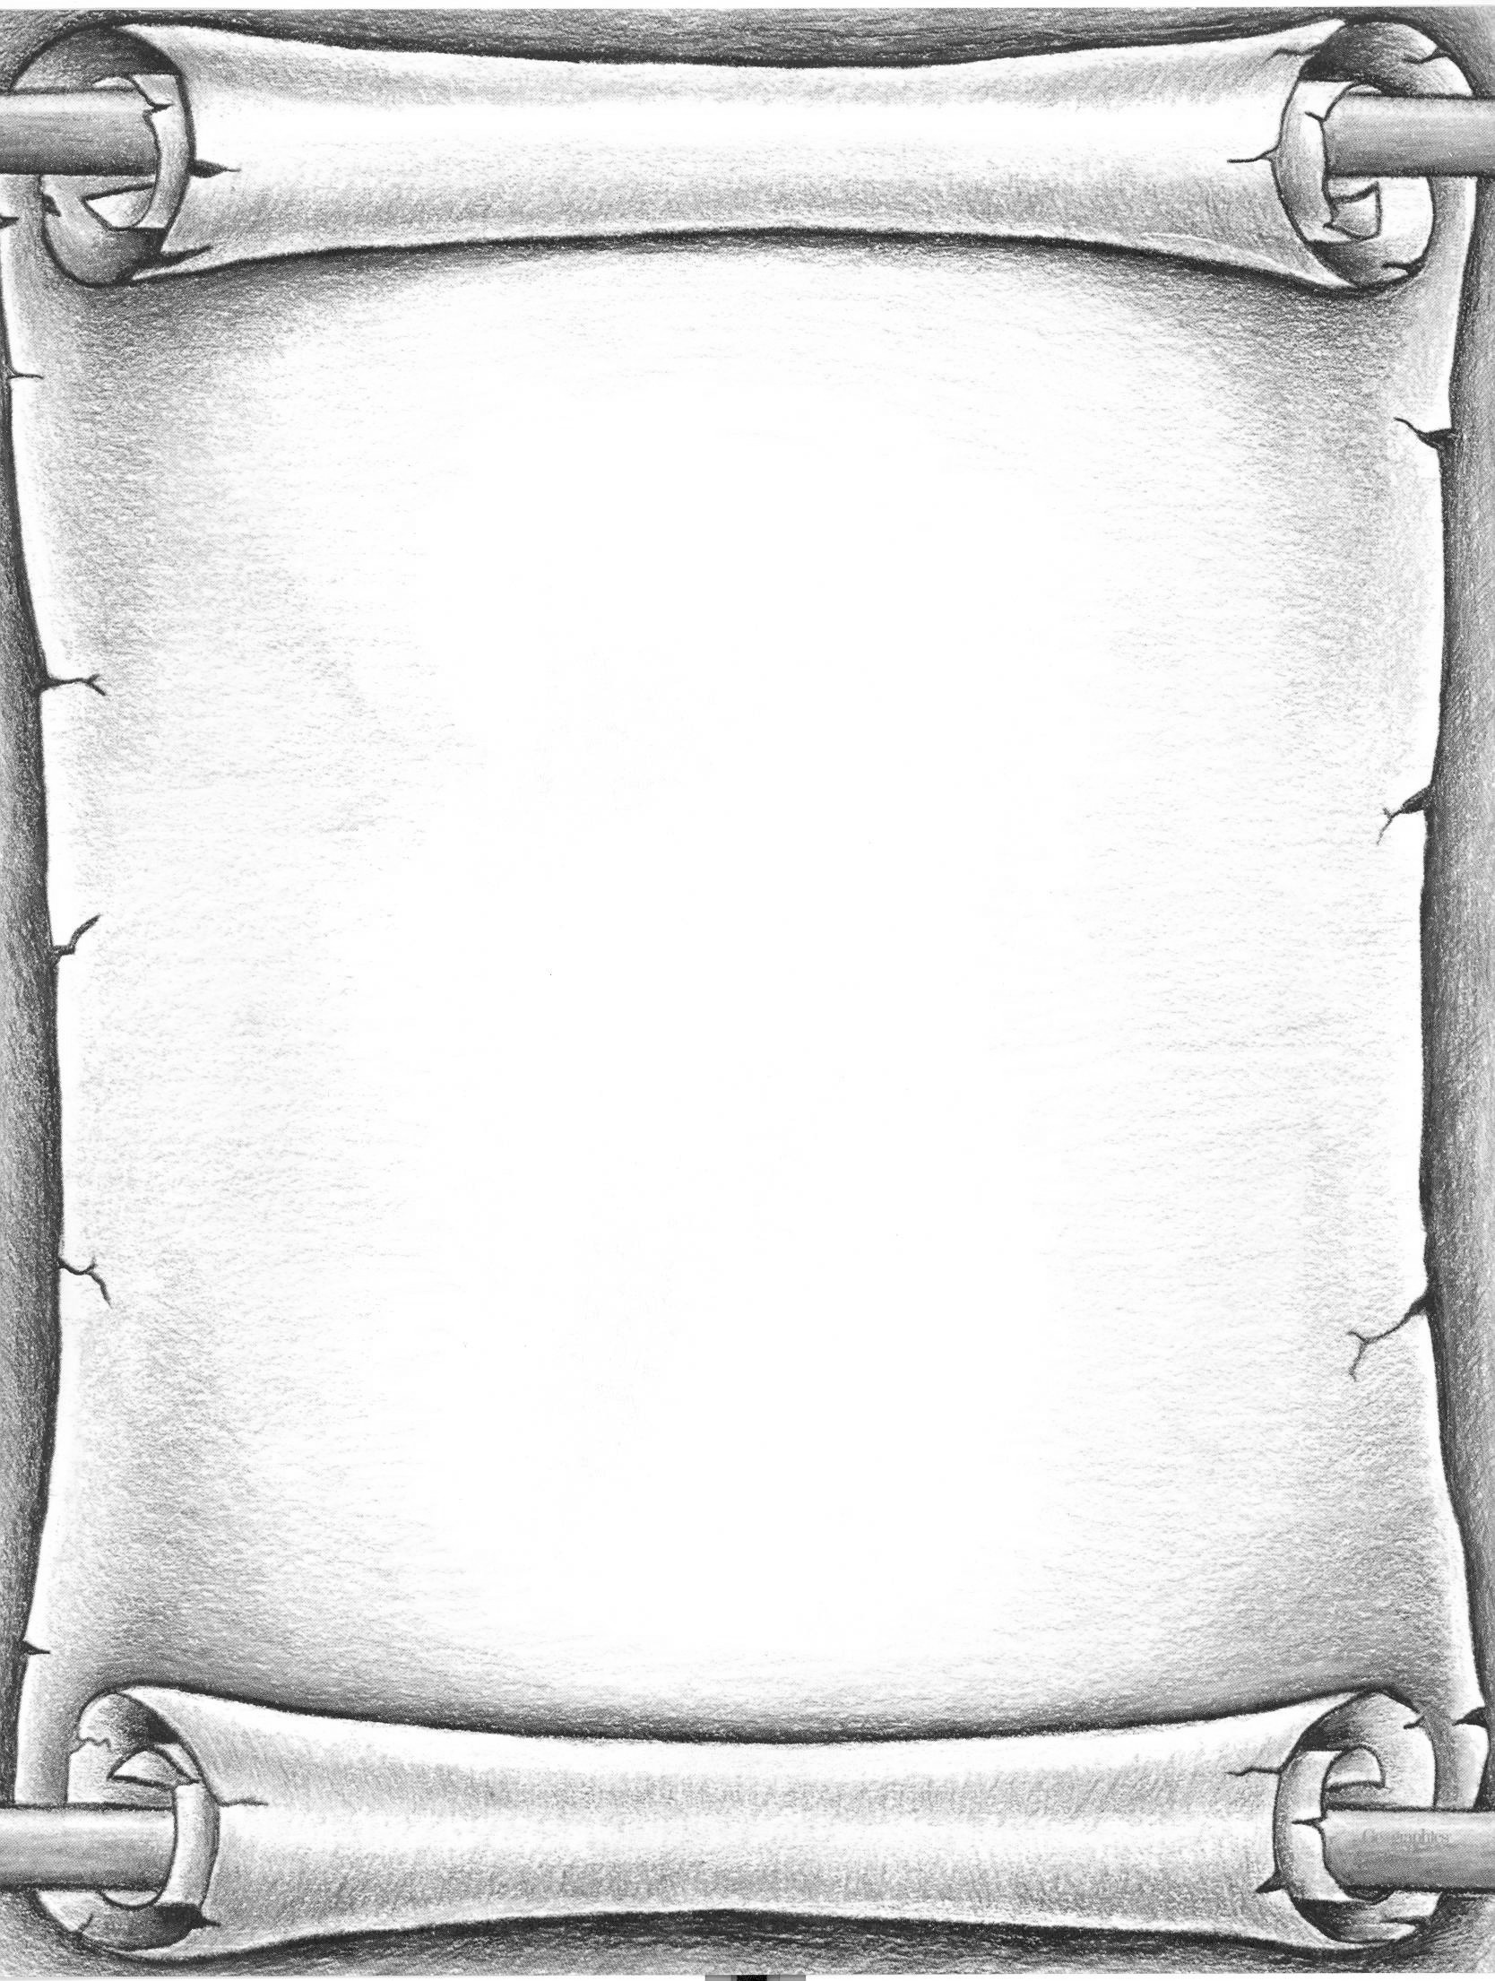
By order of his Royal Majesty, the Emperor, it is decreed that all the world is to be counted and taxed.
Therefore, let each person and family come for "A Night in Bethlehem" to be taxed according to law.
Donkeys must be tied on the south side of the building and enter through the proper gate.
Everyone must dress in "Biblical" attire to enter the city.
Bring a blanket for your family to rest on from their long journey, you may find that the Inn is full.
Each family will be assessed taxes. Watch for tax notices.
A light supper will be available in the open market.
All taxing will take place on the date, time, and place shown in the lower corner. Those found disobeying this law to appear, will be sentenced to a holiday season without the true spirit of Christmas.
So let it be written. So let it be done.

~Caesar Augustus
Date:
Time:
Place:

